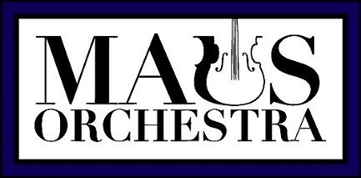
Orchestra Materials
* Natural-colored instrument and bow in good playing condition
* Rosin
* Korg Tuner with pick-up
* Soft Cloth
* Pencil (on stand)
* Black Orchestra binder with music and method book
* Rock Stop for Cello and Bass
* Shoulder Rest for Violin and Viola
* Luggage Tag on Case for Identification

Additional Materials for Home (optional)
- Music Stand (symphony must have to attend orchestra tour)
- Metronome
- CD player
- Computer microphone or other recording device (smartphone, etc.)

Textbooks for different orchestras:
When purchasing these books make sure you are getting the right one for your instrument!! (violin, viola, cello, or bass)
*Beginner Orchestra is Essential Elements 2000 for Strings, Book 1 w/cd
*Concert Orchestra is Essential Technique 2000 for Strings, Book 2 w/cd
*Philharmonic & Symphony Orchestra is Essential Technique 2000 for Strings, Book 3 w/cd
*Advanced Symphony Orchestra is Expressive Techniques for Orchestra

*- All items marked with this symbol are mandatory for the class. Students will lose points for participation per missing material.

